Draft Airspace Modernisation Strategy 2022–2040 consultation questions

About you

A Are you responding in an official capacity on behalf of an organisation?
(Required)
Please select only one item
☐ Yes
☐ No
If yes, please give us the name of the organisation

B What is your name?
(Required)

C What is your email address?
If you enter your email address then you will automatically receive an acknowledgement email when you submit your response.
Email

D Are you answering as:
(Required)
Please select only one item
☐ Airline passenger
☐ Resident affected by aviation
☐ General Aviation (GA), including representative organisations
☐ Remotely Piloted Aerial System
☐ Commercial aviation/aerospace industry including trade associations
☐ Consultancy
☐ Central or local government body including military
☐ Elected political representative e.g. councillor or MP
☐ National organisation (excluding GA organisations and industry trade associations), e.g. NGO
☐ Local organisation e.g. community action group, airport consultative committee or forum
if you fall in more than one category, choose the one that is most relevant to you answering about airspace issues
E Where do you live or where is your organisation based?
(Required)
Please select only one item
☐ East of England
☐ East Midlands
☐ West Midlands
☐ North East
☐ North West
☐ Northern Ireland
☐ Scotland
☐ South East
☐ South West
☐ Wales
☐ Yorkshire and the Humber

F Is there anything else that you would like us to know about you in connection with your response?

G Do you consent to your response being published?
(Required)
Please select only one item
☐ yes, with personal identifying information (organisation, name, respondent category, location, additional information – please note your email address will NOT be published if you choose this option)
☐ yes, anonymised
☐ no

Views on the overall strategy

1 Do you agree with our overall approach in the refreshed Airspace Modernisation Strategy?
Please select only one item
☐ about right
☐ minor modifications needed
☐ major modifications needed
☐ don’t know
If you wish, please explain your answer using the box below. You may, for example, want to consider whether our strategic vision for airspace modernisation out to 2040 is fit for purpose, and give us views on the four strategic objectives we have identified (safety, integration, simplification and sustainability).
Please note that we are not seeking views on matters of government policy, over which we have no direct control. For example, the CAA must follow government policy and guidance on environmental objectives setting out how aviation-related environmental impacts should be considered.
Nor are we seeking views on the CAP 1616 airspace change process, or on specific airspace changes or change proposals.
We will not take into account elements of responses to this consultation that we consider to be out of scope.

2 Have we captured the drivers for change adequately in Part 1, Chapter 2?
Please select only one item
☐ yes
☐ no
☐ don't know
If no, please describe what is missing or needs amendment and how this might require a change to the draft strategy.

3 Have we identified the right stakeholder groups in Part 1, Chapter 2?
Please select only one item
☐ yes
☐ no
☐ don't know
If no, please describe the missing group

Views on the delivery 'elements'

4 What are your views on the nine delivery ‘elements'?
The nine delivery ‘elements’ are in Tables 4.1, 4.2 and 4.3 in Chapter 4 of Part 1 of the strategy, with more detail in Part 2 and the linked database. In Chapter 5, we also describe five illustrative use cases relating to different aspects of modernised airspace in the 2030s from the perspective of different stakeholders.
The delivery elements are:
Please select only one item
☐ about right
☐ minor modifications needed
☐ major modifications needed
☐ don’t know
If you think modifications are needed, or that something is missing, please explain this below.

5 Part 3 of the AMS will cover who is responsible for deploying the delivery ‘elements’ and related activities, and how. At this early stage, what are your views on any requirements we should have for those tasked with the deployment of those elements and activities?

Views on AMS governance

More information on governance and funding of a broader, refreshed strategy (click here)
The 2018 Airspace Modernisation Strategy, including its delivery and governance structures, was mostly focused on commercial air transport, controlled airspace and larger air navigation service operations. Our refreshed strategy proposes adding new areas of focus, in particular around integration, for example:
- seamless integration of beyond visual line of sight drone operations
- a Lower Airspace Service to better support both self-management of piloted VFR (Visual Flight Rules) aircraft and drone operators in class G airspace
- flight progress information sharing to facilitate increased VFR access to class D airspace
- an improved class G structure
and so on.
However, not all of these new areas of focus sit readily with the current strategy's delivery and governance, and by inference funding, structures.
Currently, aside from the UK Flight Information Service provided to meet ICAO obligations, and specific arrangements for the North Sea, aircraft outside controlled airspace are either:
- not receiving a service (relying on a traditional ‘see and avoid’ means of deconfliction), or
- benefiting from navigation aids and/or air traffic services that are already established for commercial or military users.
The CAA recognises that there has to be a fair and equitable funding model for users of a modernised airspace.
We would expect to consult on this separately in due course, subject to advice from the Government. With this in mind you may want to tell us how we should alter the Airspace Modernisation Structure governance structure in the meantime, including any thoughts on future approaches to funding. We have asked two questions below.
6 How effective has the AMS governance structure been, for example in terms of overseeing delivery of the strategy, stakeholder engagement or transparency?
Below is the governance structure we last published in CAP 1862 in December 2019, which itself updated the original 2018 CAA/Department for Transport governance annex
CAP 1711b. Further changes have occurred in the last two years.
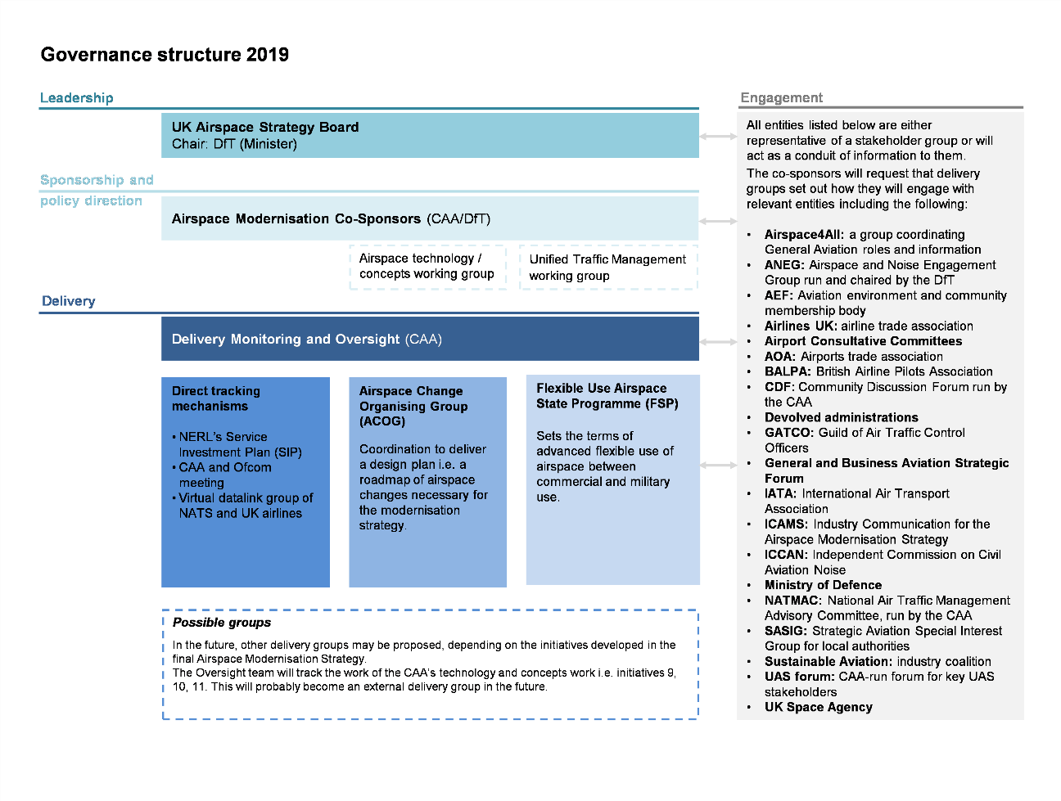
The existing governance structure has been:
Please select only one item
☐ effective
☐ generally effective but lacking in some areas
☐ wholly or mostly ineffective
☐ don’t know
Please explain the reasons for your answer. We are particularly interested to know:
- whether it is clear to you who has been responsible for what
- whether we had the right delivery groups
- whether they have been properly funded.

7 The refreshed strategy is broader in scope. What changes to governance are needed to deliver the broader strategy, including future approaches to funding?
We are particularly interested to know:
- whether the structure needs to change
- whether the co-sponsors need to do anything differently
- whether any new stakeholders not identified in the existing governance structure need to be added.
For example:
- to help with delivery of Part 2 of the strategy we might consider introducing a Deployment Steering Group made up of industry representatives at operations director level
- to help deliver airspace integration we might consider introducing an Integration Steering Group overseeing separate working groups on beyond visual line of sight operations for drones, service provision, airspace structures etc.

